CSCI567 2014 Homework Assignment 4
Student Name Yi Duan
USC ID 9966845562
I have collaborated with Meng Sun
Zhenyu Zhou

- Boosting
- Gradient Calculation
$$g_{i}=\frac{∂L\left(y_{i},\hat{y_{i}}\right)}{∂\hat{y_{i}}}=2\left(\hat{y_{i}}-y_{i}\right)$$
- Weak Learner Selection
Set $G\left(γ\right)=\sum_{i=1}^{n}{{(-g_{i}-γh(x_{i}))}^{2}}$
$$\frac{∂G(γ)}{∂γ}=\sum_{i=1}^{n}{2h\left(x_{i}\right)(g_{i}+γh(x_{i}))}=\sum_{i=1}^{n}{2h\left(x_{i}\right)g_{i}}+γ\sum_{i=1}^{n}{2{h\left(x_{i}\right)}^{2}}=0$$
Then we get
$$γ=-\frac{\sum_{i=1}^{n}{2h\left(x_{i}\right)g_{i}}}{\sum_{i=1}^{n}{2{h\left(x_{i}\right)}^{2}}}=\frac{2\sum_{i=1}^{n}{h\left(x_{i}\right)(y_{i}-\hat{y_{i}})}}{\sum_{i=1}^{n}{{h\left(x_{i}\right)}^{2}}}$$
- Step Size Selection
Set $F\left(α\right)=\sum_{i=1}^{n}{L\left(y_{i},\hat{y_{i}}+αh^{*}(x_{i})\right)}=\sum_{i=1}^{n}{{\left(y_{i}-\hat{y_{i}}-αh^{*}(x_{i})\right)}^{2}}$
$$\frac{∂F(α)}{∂α}=\sum_{i=1}^{n}{2h^{*}\left(x_{i}\right)(αh^{*}\left(x_{i}\right)+\hat{y_{i}}-y_{i})}=α\sum_{i=1}^{n}{2{h^{*}\left(x_{i}\right)}^{2}}+\sum_{i=1}^{n}{2h^{*}\left(x_{i}\right)(\hat{y_{i}}-y_{i})}=0$$
Then we get
$$α^{*}=\frac{\sum_{i=1}^{n}{h^{*}\left(x_{i}\right)(y_{i}-\hat{y_{i}})}}{\sum_{i=1}^{n}{{h^{*}\left(x_{i}\right)}^{2}}}$$
- Neural Network
- Suppose the neural network has N hidden layers. Its single logistic output is $y_{k}=σ(\sum_{j=0}^{M}{u_{kj}z_{j}})$ and linear activation function is $z_{j}=\sum_{n=1}^{N}{\sum_{i=0}^{D}{v_{ji}^{(n)}}}x_{i}$ where $σ\left(x\right)=\frac{1}{1+e^{-x}}$. Substitute $z_{j}$ in $y_{k}$ and we can get
$$y_{k}=σ\left(\sum_{j=0}^{M}{u_{kj}\sum_{n=1}^{N}{\sum_{i=0}^{D}{v_{ji}^{\left(n\right)}}}x_{i}}\right)=σ\left(\sum_{i=0}^{D}{(\sum_{j=0}^{M}{\sum_{n=1}^{N}{u_{kj}v_{ji}^{\left(n\right)}}})x_{i}}\right)$$
Set $w_{ki}=\sum_{j=0}^{M}{\sum_{n=1}^{N}{u_{kj}v_{ji}^{\left(n\right)}}}$ then we can get
$$y_{k}=σ\left(\sum_{i=0}^{D}{w_{ki}x_{i}}\right)$$
which is logistic regression.
- Suppose $a_{k}=\sum_{i=1}^{3}{w_{ki}x_{i}}$, then we can get
$$\frac{∂L}{∂w_{ki}}=\frac{∂L}{∂a_{k}}⋅\frac{∂a_{k}}{∂w_{ki}}=\frac{∂L}{∂a_{k}}x_{i}$$
$$\frac{∂L}{∂a_{k}}=\frac{∂L}{∂z_{k}}⋅\frac{∂z_{k}}{∂a_{k}}=\frac{∂L}{∂z_{k}}{(\sec{a_{k}})}^{2}$$
$$\frac{∂L}{∂z_{k}}=\sum_{j=1}^{2}{\frac{∂L}{∂\hat{y_{j}}}⋅\frac{∂\hat{y_{j}}}{∂z_{k}}}=\sum_{j=1}^{2}{(y_{j}-\hat{y_{j}})v_{jk}}$$
So the backpropagation updates for estimation of $w_{ki}$ and $v_{jk}$ is
$$\frac{∂L}{∂w_{ki}}=\sum_{j=1}^{2}{(y_{j}-\hat{y_{j}})v_{jk}}{(\sec{a_{k}})}^{2}x_{i}$$

- Clustering

$$\frac{∂D}{∂μ_{k}}=2\sum_{n=1}^{N}{r_{nk}(μ_{k}-x_{n})}=2μ_{k}\sum_{n=1}^{N}{r_{nk}}-2\sum_{n=1}^{N}{r_{nk}x_{n}}=0$$
Then we can get
$$μ_{k}=\frac{\sum_{n=1}^{N}{r_{nk}x_{n}}}{\sum_{n=1}^{N}{r_{nk}}}$$
which means if $μ_{k}$ is the mean of all data points assigned to the cluster k for any k, then the objective D is minimized.
- According to the description,
$$D=\sum_{n=1}^{N}{\sum_{k=1}^{K}{r_{nk}{||x_{n}-μ_{k}||}_{1}}}=\sum_{n=1}^{N}{\sum_{k=1}^{K}{\sum_{d=1}^{D^{'}}{r_{nk}|x_{nd}-μ_{kd}|}}}$$
We can easily prove that given {x₁, x₂, …, x_{n}}, ${argmin}_{μ}\sum_{i=1}^{n}{|x_{i}-μ|}$ is the median of {x₁, x₂, …, x_{n}}. When r_{nk} = 0, the corresponding value is 0. Thus, we only need to consider the situation when r_{nk} = 1, which is
$$D=\sum_{x_{n} is assigned to μ_{k}}^{N,K}{\sum_{d=1}^{D^{'}}{|x_{nd}-μ_{kd}|}}$$
Then we get
$${argmin}_{μ_{kd}}D=median\left\{set\{x_{nd}\}\right\},where x_{n} is assigned to μ_{k}$$
which means $μ_{k}$ is the elementwise median of all data points assigned to $μ_{k}$.
- Mixture Models
- The log-likelihood in terms of unobserved variables X_{i} is
$$\log{P\left(X_{1},X_{2},…,X_{n}\right)}=\log{\prod_{i=1}^{r}{λe^{-λx_{i}}}}\prod_{i=r+1}^{n}{\int_{c_{i}}^{+∞}{λe^{-λx}dx}}=\operatorname{rlog}{λ}-λ(\sum_{i=1}^{r}{x_{i}}+\sum_{i=r+1}^{n}{c_{i}})$$
- We can get the expectation
$$Q(λ,λ^{(t)})=E_{X_{r+1},…,X_{n}|Y_{r+1},…,Y_{n}}\left[\log{P\left(X_{1},X_{2},…,X_{n}\right)}\right]=E_{X_{r+1},…,X_{n}|Y_{r+1},…,Y_{n}}[\operatorname{rlog}{λ}-λ(\sum_{i=1}^{r}{x_{i}}+\sum_{i=r+1}^{n}{c_{i}})]=E_{X_{r+1},…,X_{n}|Y_{r+1},…,Y_{n}}[\operatorname{rlog}{λ}-λ\sum_{i=1}^{r}{x_{i}}]-E_{X_{r+1},…,X_{n}|Y_{r+1},…,Y_{n}}[λ\sum_{i=r+1}^{n}{c_{i}}]=\operatorname{rlog}{λ}-λ\sum_{i=1}^{r}{x_{i}}-λ\sum_{i=r+1}^{n}{c_{i}}\int_{c_{i}}^{+∞}{λ^{(t)}e^{-λ^{(t)}x}dx}=\operatorname{rlog}{λ}-λ\sum_{i=1}^{r}{x_{i}}-λ\sum_{i=r+1}^{n}{c_{i}}e^{-λ^{(t)}c_{i}}$$
- Set the derivation of expectation respect to $λ$
$$\frac{∂Q(λ,λ^{(t)})}{∂λ}=\frac{r}{λ}-(\sum_{i=1}^{r}{x_{i}}+\sum_{i=r+1}^{n}{c_{i}}e^{-λ^{(t)}c_{i}})=0$$
Then we get
$$λ^{(t+1)}=\frac{r}{\sum_{i=1}^{r}{x_{i}}+\sum_{i=r+1}^{n}{c_{i}}e^{-λ^{(t)}c_{i}}}$$
- Programming
- K=2
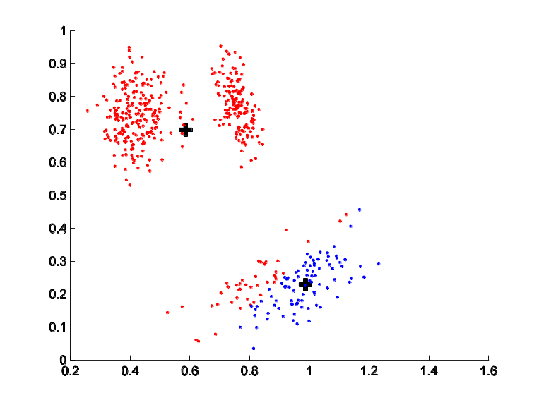
K=3
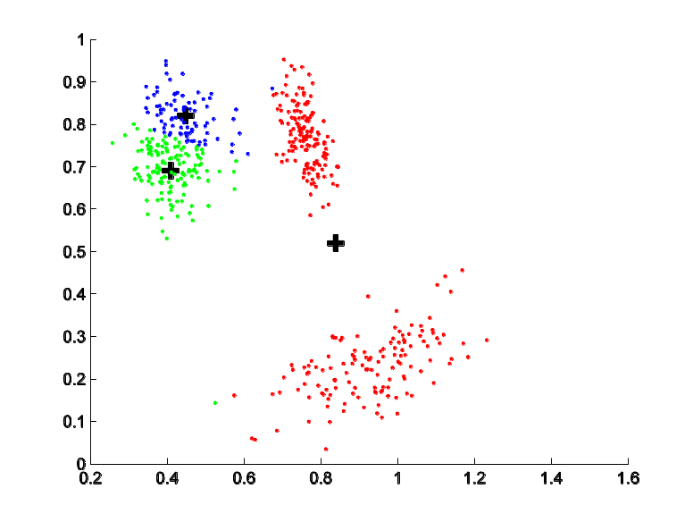
K=5
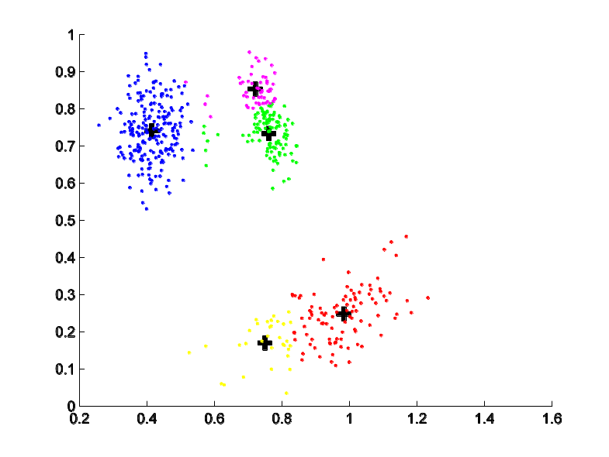
- K=4
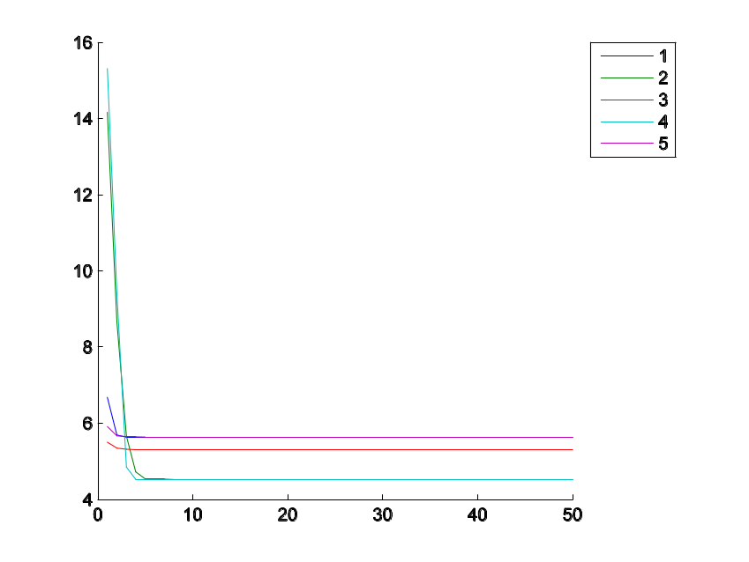
- K-means always converge after finite number of iterations as it reduces J in each step. Since J has lower bound 0, the procedure cannot be infinite.
- K=3
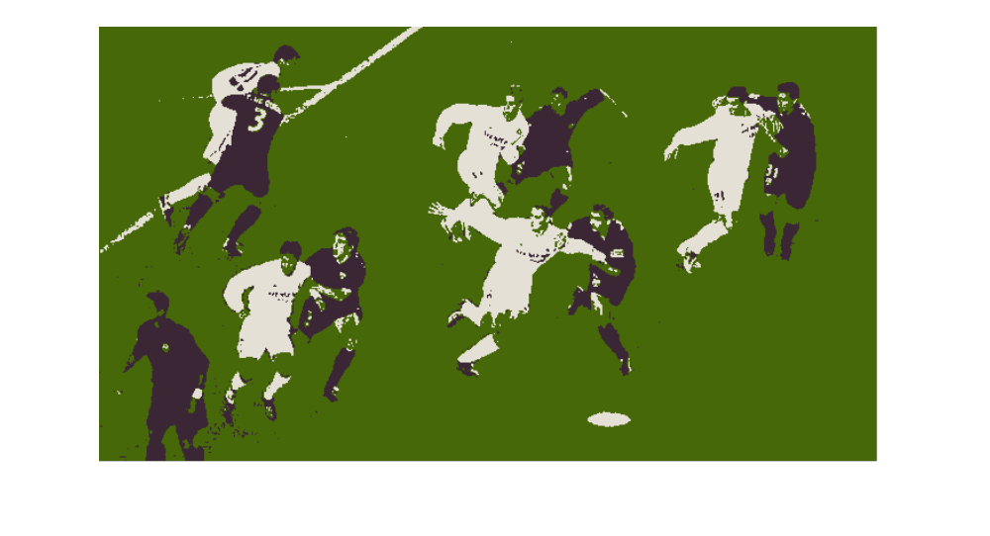
K=8
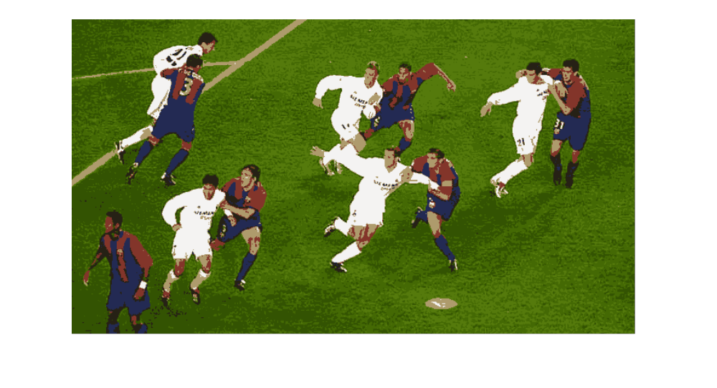
K=15
